AEQUOR Technologies Inc.,

33, Wood Avenue South

5th Floor, Iselin, NJ 08830

USA



**SourceESB – Back office operations – Ad Production Management**

**STATEMENT OF CONFIDENTIALITY**

Copyright © 2008-2010, Aequor Information Technologies Pvt. Ltd. All rights reserved. This product or document may not, in whole or in part, be copied, photocopied, reproduced, translated, or reduced to any electronic medium or machine readable form, by any means electronic, mechanical, photographic, optic recording or otherwise without prior consent, in writing, of the copyright owner.

**Change Record**

|  |  |  |  |
| --- | --- | --- | --- |
| Author | Date | Reason For Changes/Description | Version |
| Ramanathan S | Wed Nov 24, 2010 | Initial Draft – Back office Ad Production Management | Ver. 0.1 |
| Ramanathan S | Tue Jan 4 2011 | Review corrections from Tina | Ver. 0.25 |
| Ramanathan S | Thu Jan 6, 2011 | Review corrections after discussions with Tina and Kathy | Ver. 0.5 |
| Ramanathan S | Jan 24, 2011 | Review corrections after Tina’s comments | Ver 1.0 |
| Ramanathan S | Jan 26, 2011 | Review – ad Proof Method added to the document | Ver 1.1 |
| Ramanathan S | Feb 8, 2011 | Review – Changes suggested by Tina | Ver 1.2 |
|  |  |  |  |
|  |  |  |  |
|  |  |  |  |
|  |  |  |  |

**Table of Contents**

1 Introduction 3

1.1 Scope 3

1.2 Scope Risks 3

1.3 Definitions and Acronyms 3

1.4 References 3

2 Requirement Specification 3

2.1 Requirements Table, 3

3 User Interface Design 3

4 Inputs required 3

4.1 Edit an Ad Job Folder 3

4.2 Submit Ads to Advertiser for Approval 3

4.3 Create Ad Job Folders 3

4.4 Delete an Ad Job Folder 3

4.5 Change Ad Job Folder Status 3

4.6 View Previous Ad Job Folder Information 3

4.7 View and Approve Artwork 3

5 Outputs Expected 3

6 Requirement Analysis and Understanding 3

7 Un-Stated Requirements 3

8 Process Flow and Design 3

9 Database Changes 3

10 Database Tables Created/Updated 3

11 Stored Procedures Created/Updated 3

12 Development 3

12.1 C# Classes Created/Updated 3

12.2 ASP.net Pages Created/Updated 3

12.3 Configuration Settings 3

13 Assumption, Constraints and Limitations 3

14 External Interfaces 3

15 Dependency Details 3

16 Penton Acceptance 3

17 Miscellaneous Notes 3

18 Appendices 3

**List of Figures**

Figure 1 Ad Job Folder Filter and Sort Criterion 3

Figure 2 Ad Job Folder Edit 3

Figure 5 Print Ads for Customer Approval Search 3

Figure 6 Ad Approval Details 3

Figure 7 Print Ad States - Business Rules for change of Status 3

Figure 9 Ad Job Folder Approval - Company Self Service 3

# Introduction

## Scope

The Penton organization is in the publishing and Web media environment focusing on industry specific publications. This organization has multiple divisions that update and introduce products to industry sectors (i.e.: electronics, investing, farming).

Electronic Source Book (ESB) is a division of Penton Media. The division is responsible for publishing electronic product directory called the SourceESB. The SourceESB is the premier directory electronics component buyers and design engineers who source electronic products and services. Manufacturers, distributors and value-added vendors (VAV) use SourceESB to advertise their products and services. Since founded in early 80s, it has become the number one directory in the electronics industry. Providing accurate, up-to-date information in an easy-to-use format, SourceESB is an invaluable link between buyers and sellers.

The system consists of a Portal which is accessed by the buyers and sellers (Distributors as referred by Penton) of the electronic components. The portal is administered by the Penton Administrators and content publishers. Several transactions happen in the portal which is captured by the application.

Sales Management deals with the distributor orders for advertising in the book or web. The Ad Production Management deals with the advertisement art works that are needed to be printed on the book or shown online. The ads are edited and saved in a specific folder that enables the print or online pick details appropriately. Most of the Ad production is initially generated by a sales order and are updated by the production persons.

## Scope Risks

After completion of analysis phase, any change in scope/assumptions would be handled through a Change Request process. Aequor shall be conducting internal reviews to ensure the project metrics are properly tracked and any risk, issues are escalated proactively and mitigated before their possible occurrence.

## Definitions and Acronyms

| **S#** | **Abbreviation/Acronym** | **Meaning** |
| --- | --- | --- |
| 1. 1 | AIF | Artwork Instruction Form – the artwork is a part of the web / print online which is developed by the clients and Penton to be displayed or printed. Instructions are provided for Penton to carry out the art work which is available in this form. This can be updated to just a text / comment field and keep the special instructions field as in the current system for print. The online AIF will need to be adjusted based on any new requirements. |

## References

1. User Requirements Document Penton SourceESB redesign
2. Systems requirements document Penton SourceESB
3. Discussions with the client

# Requirement Specification

## Requirements Table[1],[2]

| S.No | Requirement Category | Requirement Statement | Source |
| --- | --- | --- | --- |
|  | Edit an Ad Job Folder | Edit an ad job folder in the system. This is similar be it a print job folder or an online job folder. | URD |
|  | Submit Print Ads to Advertiser for Approval | Submit ads to the advertiser for approval | URD |
|  | Create Ad Job Folders | The ad job folders are created automatically after an order is signed by the customer[3]. This is similar be it a print ad or an online ad. | URD |
|  | Delete an Ad Job Folder | An Ad Job folder is deleted when the order is cancelled.[4] The Ad Job folder is physically removed from the system. | URD |
| 1. . | Change Ad Job Folder Status | The business logic for Ad Job folder operations and status | URD / System requirements |
|  | View and Approve Artwork | An advertiser shall have the ability to view and approve artwork for their advertisements in print and Online. | URD |

# User Interface Design

This is covered in Section 4 and 5 showing the inputs and outputs required. The screen layouts provide the details that are input or results obtained. The landing page is also shown in the input / output section.

# Inputs required

## Edit an Ad Job Folder

The ad production manager, production coordinator and artist shall have the ability to edit an ad job folder in the system. This is available for both online and print ads.

An ad job folder is associated with an advertiser per edition and order. The Production[5] shall have the ability to view the ad order, artwork instructions and the history of the job folder. The Ad production team can copy the contents of a previous edition’s Ad file and edit only the job folder instructions suitably.

The ad production team including the artist manager and coordinator shall have the ability to[6] [7]

* edit the special instructions,
* change the job status and
* maintain the artwork charge.

An artist can

* edit an ad file (by using the In-Design / QUARK tool and associated software packages – Illustrator, Photoshop),
* add comments in the job folder and
* indicate that the ad file is complete[8].

An ad-Job folder is created when an Ad-Order is signed by the Advertiser[9][10]. The Ad Job folder would contain an order reference and customer reference to begin with[11]. There are some types of ads that do not require job folders. An example would be a buy button. No artwork necessary. This would also be true for market intelligence reporting. If the ad type is any of these, identified by a flag in the AD – (Needs to be added in AD Order Management) , there will be no AD JOB FOLDER created. There is also basic information in the job folder consisting of company name, online / print, ads purchased, special instructions, ad proof ability, Ad Job folder status. Once an Ad-Job folder is created, it can be edited by the Production[12]

The landing page enables the user to search for the specific Ad Job folder. The filter and sort criteria are as follows: (Refer Figure 1 Ad Job Folder Filter and Sort Criterion for details).

* Filter: Edition [13](default to this year), Advertiser, Status
* Sort: Advertiser/edition or edition/advertiser

The sales coordinator shall have view only right to the ad job folder when the job folder status is Pending[14].

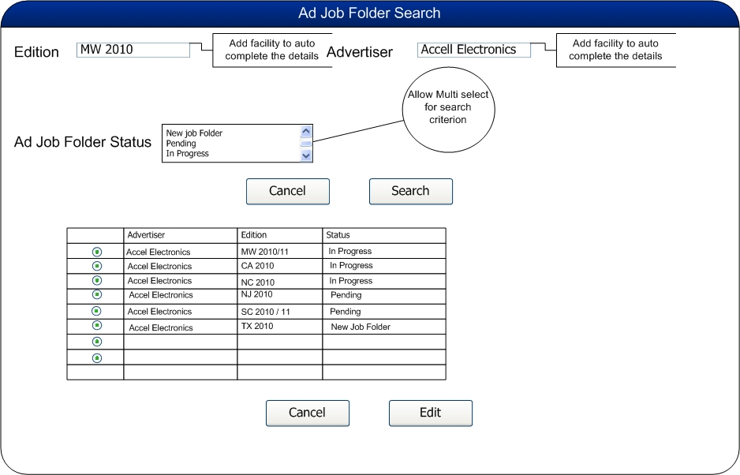

Figure Ad Job Folder Filter and Sort Criterion

A list of ad job folders according to the filter and sort criteria are displayed as in Figure 1 Ad Job Folder Filter and Sort Criterion. The user selects a job folder to edit. The following screen (refer Figure 2 Ad Job Folder Edit) is displayed. The information is grouped under

1. Advertiser Info providing the following details:
   1. Advertiser name – From the Ad order – not editable, populate from order
   2. Job Folder Status – editable list box. For a Print order the following list of status is applicable:
      1. New Job Folder – when the order is created.
      2. Pending
      3. In progress
      4. Pending Advertiser Approval
   3. Type of order (i.e. Online or Print) – not editable and is picked from the Ad Order[15].
   4. Edition – not editable and is picked from the Ad Order.
   5. Art Work Charge – This is usually ZERO[16]. The amount if any, should link automatically to invoice[17].
2. Order Status[18] – whether it is a new / existing or a revised order. This is determined by the Ad Order and the appropriate text appears.

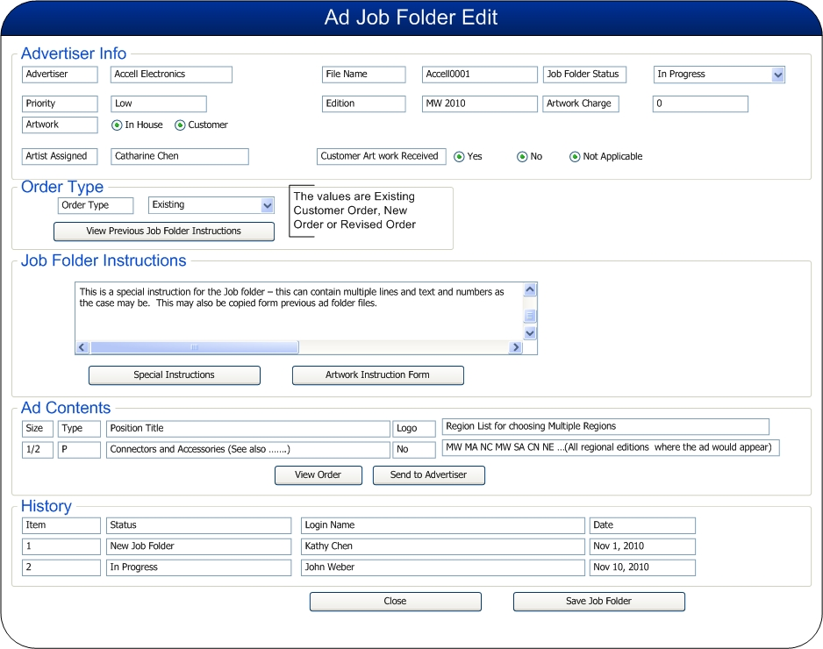

Figure Ad Job Folder Edit[19]

1. Job Folder Instructions – that gives all instructions for the art work / special instructions etc. about the Job Folder.
2. Ad Contents – regarding the position title, Size, Type, Logo and the region list – where the Ad should appear. These appear from the Ad Order.
3. The History of the Ad Job folder – changes to the Ad Job Folder is recorded with date and person who made the changes.

The user has the option to

1. Edit the job folder status (More details are found in Change Ad Job Folder Status). All valid users can change the status appropriately.
2. Review the ad order or the artwork instruction form.
3. Edit job folder instructions. If the user is Production[20][21]
   1. Edit special instructions.
   2. Open and view another folder’s instructions (refer View Previous Year’s Ad Job Folder Information). Refer TINA – **Figure 4 View Previous Job Folder Instruction** for more details.
   3. Submit the ad to advertiser for approval. (Refer Submit Print Ad to Advertiser for Approval).
4. Indicate that the modification is completed[22].

The system records the job folder and maintains a history.

There are 10 editions each year for ESB publishing currently. This may be changed in the future as SourceESB goes international. The current sequence of publishing these editions is as below:

1. Mid Atlantic
2. Northern California
3. Mid West
4. Southern California
5. South Atlantic
6. Central States
7. New England
8. Northwest
9. Mountain States
10. Canada

The future editions could be increased and may include several languages also.

**Data Requirements:**

| Ad Job Folder Data Table | | | |
| --- | --- | --- | --- |
| **Data Name** | **Type** | **Can Edit** | **Remarks** |
| Edition | C[23] | N | Region and Year |
| Advertiser Name | C | N | From the order |
| Order Link |  | N |  |
| Order Status[24] | C | N | Print or online |
| File Name | C | N | Populate from advertiser name |
| Job Folder Instructions | C |  | Memo |
| Status | C |  | The status as recorded above. The section on Change Ad Job Folder (Refer Section 4.4 for more details). |
| Status Comment | C |  | Provides explanation to pending status – Text |
|  |  |  |  |
| Special Instructions Link[25] |  |  | Production manager, coordinator provide this detail –Text [26] |
| Ad Content Link |  | N | From the Order |
| Artwork Charge | $ |  | It will be linked to the invoice. This needs to be linked to the Billing System. Currently, it is always ZERO.[27] |
| Advertiser Approval Link |  |  | Link to approval form |
| Customer's Comment | C |  | received during the proofing process |
| Associated Previous Edition Ad File Link | C |  | Choose one from the last 10 editions[28][29] |
| History Links[30] |  | N | User, date System generated and maintained |

## Submit Ads to Advertiser for Approval

Only the ad production manager or coordinator has the ability to submit ads to the advertiser for approval. This happens when the ad production manager clicks the send to advertiser. An email alert is sent to the advertiser. This is the same for both print ads and online ads. However, it is expected that there is no wait [31]for the approval from the advertiser for te Online Ads. For the print ads, there is a need for approval and it is awaited from the client. The system will send an alert to the advertiser – note that the sales order has an Approved By person to whom the mail is sent for Ad proof approval. The alert would be sent in an EMAIL form. There will be no Fax formats in the SourceESB system.

* If the indicator is email, the ad production manager or coordinator can add comments and deadline on a proof form. The system should provide the ad image file link to the proof form. The system shall send the email to the advertiser with a link of to the ad proof form.

Penton would prefer to have the system where Email is predominantly used for the communication.

* The ad job folder should be in Pending Advertiser Approval. Refer Print AD State Diagram

The artist completes the artwork and once the art work is approved by the ad production manager or coordinator it can be submitted to the advertiser for approval. The Print Ad Job folder for Approval search screen (Refer Figure 3 Print Ads for Customer Approval Search) is used to retrieve all jobs that are with Status in Pending Advertiser Approval. The system retrieves the advertiser contact details with the company details.

1. Company Name (from job folder)
2. Contact Name (from order)[32]
3. Edition (from job folder)
4. Ads file link (hotlink)

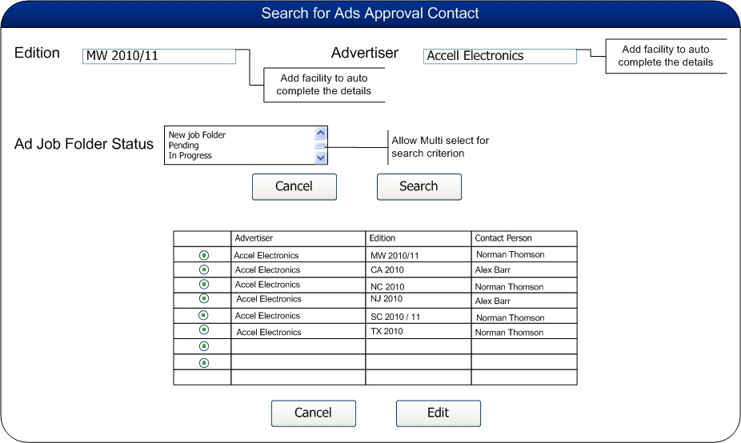

Figure Print Ads for Customer Approval Search

The user can enter a deadline if needed and a set of comments. (Please refer Figure 4 Ad Approval Details[33]).

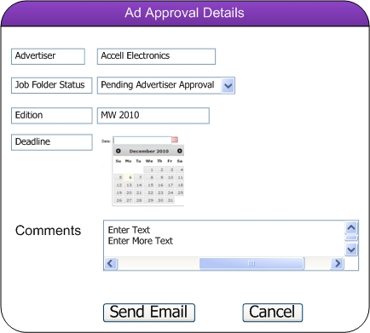

Figure Ad Approval Details

The Penton user can click on Send Email or cancel[34]. Cancel would take the user to the search screen.

The email format is as shown below:

Dear <Company Contact name>,

Thank you for the opportunity to further support your sales and marketing efforts with our online product.

Below is the link to preview the online ads for <company name>.

<http://www.esbprod.com/prf.asp?ID=A478D666-4584-40F6-9E7C-902D22AA5B55> <Link for the Job Folder> or alternately a PDF attachment as necessary.

These ads will be activated on our Web site, [http://www.sourceESB.com](http://www.sourceesb.com/), by <Publishing date>.

If you have any questions, please contact your Account Manager by <due date>.

You may reach your Account Manager by calling <account manager telephone number>.

Sincerely,

ESB Online Production

For Print ads, the proof is sent in a PDF format to the advertiser.

For online ads - there needs to be a way to check in the banner ads and the logos. The text ads could be in the AIF or a place where it can be added and edited throughout the life of the ad. All of this is put on a proof form with a link sent to the advertiser to review (Refer Figure 5 Details of an Online Ad for proofing for details). No sign off is necessary in the online either case.

If print ads are not signed off with in a specific time line determined by production then another e-mail is sent stating that if we do not hear back within x amount of days then your ads will be published as is.

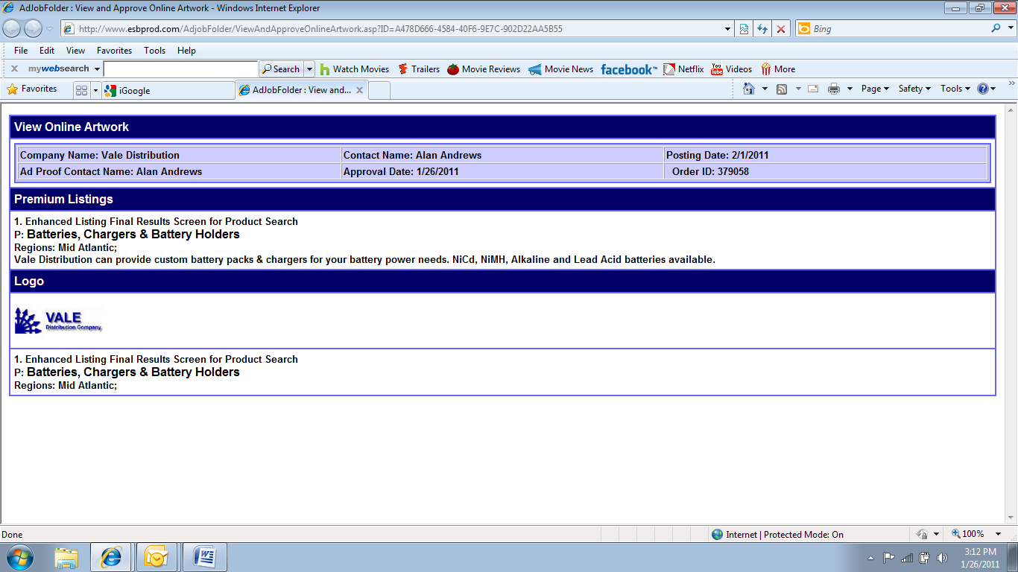

Figure Details of an Online Ad for proofing

The system also records the transaction audit with the Login Id, Date/Time and Transaction Type.

## Create Ad Job Folders

The ad job folders are created automatically after an order is finalized by production.[35]. The job folders are associated with the new order. An artwork instruction form is associated with every order[36]. When production finalizes the order, the system gets the number of editions from the order and creates an ad job folder for each print edition. Please note that there would be a single job folder for the online order. [37]

Each job folder contains advertiser name, edition, order type, file name and a copy of order content with the current edition highlighted.

When a new ad order is released, the advertiser name, number of edition, order type from the order and file name from the advertiser are available. For each edition, an Ad Job folder with the file name, advertiser name, edition, order type, folder status (In Progress), association with the order and artwork instructions are generated. The system copies order contents into each job folder and highlights the edition of the job folder it pertains to.

**Business Rules[38]**

* Once the order is generated the Sales Coordinator makes sure the AIF is attached before the job folder is created[39].
* The application tracks the revised orders submitted by the sales reps and automatically notify the Ad Production Manager and Production Coordinator of revised orders by sending an alert to the ad production department[40].

## Delete an Ad Job Folder

An ad job folder gets marked for deletion when the order gets marked for deletion. The folder is deleted when the order is deleted. When an order is deleted, the system should delete an ad job folder that is associated with the order. The production manager coordinator is notified of the deletion through an email alert.[41] This is usually done through a change order process. Please note that if there is a name change or a new sales rep is assigned to a company the job folder should not be deleted.

## Change Ad Job Folder Status

This section lists the various business rules involved in managing an Ad Job Folder.

1. When the production staff finalizes an ad the system will generate a job folder for each edition specified on the order. The system marks each job folder as New Job Folder. The ad production coordinator can run a search on all new job folders by an edition.
2. The production coordinator can change the job folder from New Job Folder to either Pending or In-Progress depending on information received[42].
3. The production manager or coordinator can change the job folder status from In-Progress to Pending if they do not have enough information to continue working on the job folder. The information may be needed in the following situations:
   1. New Artwork,
   2. Need Logo,
   3. Need Instructions,
   4. Need R/O (revise order),
   5. Need to Add Ads,
   6. Need to Delete Ads,
   7. Proof Contact Change, Change Phone #, Change Address, Change Email and Change Web URL. (This additional information could be put into Status Comment field)
4. The production coordinator or manager can change the job folder status from Pending Ad Production Manger Approval to In-Progress if they reject the artist work on the Ads. The system will record the transaction and generate an alert for the artist.
5. The production coordinator or manager shall change the job folder status from Pending Ad Production Manger Approval to Pending Advertiser Approval and submit the ads to advertiser for approval. The system will check that if any job folder hasn’t received advertiser’s approval / reject notice in 3 days[43] after ad production manager submitted the ad to advertiser. The system will notify through an alert to the ad production department. It is left to the ad production department to make further decision.
6. The system will change the job folder status from Pending Advertiser Approval to Advertiser Approved if the advertiser approved the ads. The system will record the transaction and generate an alert for production manager coordinator.
7. The system will change the job folder status from Pending Advertiser Approval to Pending Changes from Advertiser if the advertiser rejected the ads. The system shall record the transaction and generate an alert to the production manager coordinator. The production coordinator or manager will change the job folder status from Pending Changes from Advertiser to In-Progress when decision to make changes is finalized. The system will record the transaction.
8. The production manager or coordinator will change the job folder status from Advertiser Approved to Pending or In-Progress if they receive a revised order notice. The system will record the transaction. The system will generate an alert if the status is changed to In-Progress.
9. The production manager or coordinator will change the job folder status from Production Ready to Pending or In-Progress if they receive a revised order notice. The system will record the transaction. The system will generate an alert if the status is changed to In-Progress.
10. The system will change the job folder status from Pending Changes Approval Advertiser Approved status if the[44] advertiser approved the ads. The system shall record the transaction and generate an alert for production coordinator or manager.

The details are schematically shown in Figure 6 Print Ad States - Business Rules for change of Status.

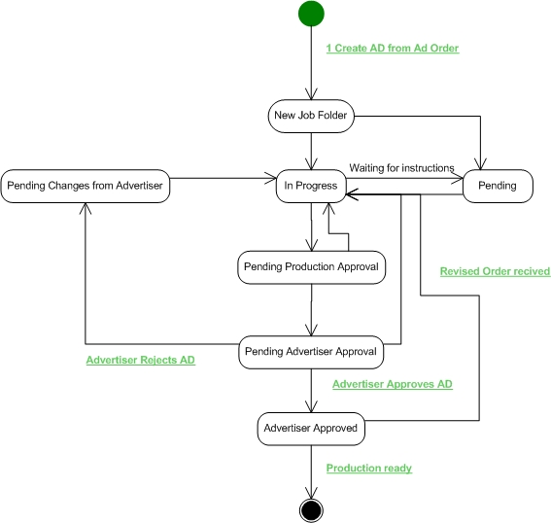

Figure Print Ad States - Business Rules for change of Status

## View Previous Ad Job Folder Information

Ad production manager or production coordinator can view a previous Ad job folder’s instructions[45].

The user is editing a job folder. When the user clicks the View Previous Job Folder Instruction., the user gets the screen as shown in **Error! Reference source not found.**. The user enters the number of editions to retrieve and the system displays the specified number of previous editions for the advertiser. On selecting the desired edition, the system displays the same and user can close the screen to go back to the Ad Job folder Edit details.

## View and Approve Artwork

An advertiser can view and approve artwork for their advertisements on the web site. When the production manager or coordinator submits an ad file for review, the system will email the appropriate advertiser with a URL link for viewing the ad file. The following information should be in the form and mail content:

Proofread carefully[46]!

The artwork on this page was prepared according to your signed advertising order. We will correct any errors which you call to our attention. Changes must be submitted in writing. Alterations not indicated originally will be charged extra. When this piece is released for production, advertiser assumes all responsibility for the content[47]) and position of ads. Please check one of the options below:

* Approved for production (radio button)
* Approved with changes (radio button)
* Make changes; re-submit for approval (radio button – only applied to print ad proof form) (If all above radio buttons remain unchecked, we will consider the ad proofs approved.)

Please ensure that the option is selected and indicate the comments if any. The details are shown in . This is a part of the Company SELF SERVICE.

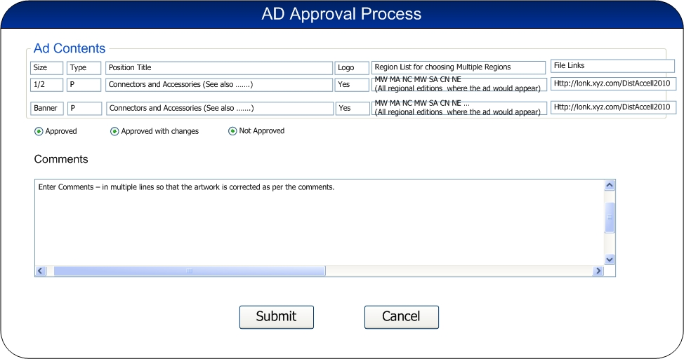

Figure Ad Job Folder Approval - Company Self Service[48]

For print there would be an artwork / proof form by edition not by ad.. A comments field next to each ad type might be helpful. Currently online is 1 ad at a time and print is 1 file at a time with multiple pages.[49]

The advertiser reviews the ad file – the links are shown in the contents, documents any comments and indicates approval, rejection or approved with changes.

The ad production manager or coordinator submits an artwork approval request to the advertiser. The advertiser contact for approving the Ads logs in to view the artwork online. The ads are displayed to the user. The ad exists in the system – this will be checked by the system.

1. The system retrieves and displays the ad proof form with the ad file link.
2. The advertiser clicks the ad file link and proof reads the ads.
3. The Advertiser can select one of the following options:
   1. Approve for production
   2. Approve with changes
   3. Make changes; re-submit for approval – in this case the art work is not approved.
4. The advertiser has the option to enter comments with the approval notes and then submit the approval.
5. The system creates an alert for ad production department regarding the status. The audit trail is logged in the transaction history.
   1. Login Id
   2. Date/Time
   3. Transaction Type

**Data Requirements:**

|  |  |  |  |
| --- | --- | --- | --- |
| Data Name | Type | Can Edit | Remarks |
| Company Name | C | N | Automatic from system |
| Edition | C | N | Automatic from system |
| Contact Name | C | N | Automatic from system |
| Deadline | D |  |  |
| Ads Link |  | N | Automatically generated by system |
| Approval | C |  | Approved, Not Approved or Approved with changes |
| Ad Proof Contact Name | C |  | Automatically populated by system |
| Customer Comment | C |  | Text to be entered |
| Comment From ESB | C |  |  |
| Approval Date | D |  | Automatically populated by system |

# Outputs Expected

All The details are discussed in Section 4 and the output expected in this case is the database updates as detailed in the section above.

# Requirement Analysis and Understanding

*<Description of Analysis by the Development Team>*

# Un-Stated Requirements

There are no unstated requirements at this stage.

# Process Flow and Design

There is no process flow / work flow involved in this case.

# Database Changes

*<This Section will be prepared by the Development Team>*

# Database Tables Created/Updated

*<This Section will be prepared by the Development Team>*

# Stored Procedures Created/Updated

*<This Section will be prepared by the Development Team>*

# Development

*<This Section will be prepared by the Development Team>*

## C# Classes Created/Updated

*<This Section will be prepared by the Development Team>*

## ASP.net Pages Created/Updated

*<This Section will be prepared by the Development Team>*

## Configuration Settings

*<This Section will be prepared by the Development Team>*

# Assumption, Constraints and Limitations

*<This Section will be prepared by the Business Analyst and updated by the Development Team>*

# External Interfaces

*<The Section will be prepared by Business Analyst with the input from Penton and will be updated by the Development Team>*

# Dependency Details

*<This Section will list down the dependencies to the External System. This section will be prepared/updated by Business Analyst and the Development Team>*

# Penton Acceptance

*<This Section will be updated by Penton>*

|  |  |  |  |
| --- | --- | --- | --- |
| **Phase** | **Approved By** | **Approval Date** | **Remarks** |
| Requirements Freeze |  |  |  |
| Process Flow and Design Acceptance |  |  |  |
| Delivery Acceptance |  |  |  |

# Miscellaneous Notes

*<This section will have the miscellaneous notes – will be added/updated by Business Analyst, Penton and the Development Team>*

# Appendices

*<Append the different Appendix to this Section. This section will be updated by Business Analyst, Penton and the Development Team>*

1. TINA: Is the reason we are checking in ads for proofing purposes? RAM: Check out and Check in Ad files is removed since they are done outside the system. Facilities existed in the IMAP system but were not used.
2. View Previous Ad Job Folder Information Ability to view a second job folder’s instructions is removed as per Tina’s comments below.

   Tina: This isn’t necessary since we should have the ability to search the previous ad job folder. Almost as if you could do a search on last year’s job folder as well as this years.
3. Tina: An ad job folder is created once an order is signed not created. It would occur once we receive a signed order and production would change the order state to final.
4. Tina: No, the system automatically deletes a job folder once the order is cancelled. If the company name changes or if the order is split due to changes with sales assignment, the ad job folder should remain. This information should be provided in a change form. Agreed as per changes requested to URD and updated as is.
5. Tina: In the new system we will have production only not ad production manager, production coordinator and artist. – Rams: Changed as per this comment from Tina.
6. TINA: Not necessary to assign to an artist. Once the order is signed a job folder is created. This would be in a “new” state. It is productions responsibility to move the job folder to In-progress or Pending which will then be available for the artist to work on. – RAM: State diagram to reflect this change and language.
7. View the ad file – This refers to the actual AD and since this is done outside the system, it is removed.

   Similarly Job priority is also not necessary. – As per Tina’s comments
8. Status change – yes Agreed. The status is changed to Production Ready.
9. TINA: Advertiser is a company – who can be a manufacturer, distributor or a value added vendor. At this time, we are assuming that the buyer companies may not want to advertise. If that is also allowed, we have to accommodate the same. Please note that an AD Order is created by a Sales Person. RAM: Agreed – and can be accommodated by using the concept of a Company as defined in our Portal.
10. An advertiser can be anybody. An end user/buyer may advertise but not by distributor or manufacturer. They may purchase market Intelligence, etc. An ad order is created once the signed order is received and editorial changes the status of the order. The sales person cannot do this.
11. TINA: There are some types of ads that do not require job folders. An example would be a buy button. No artwork necessary. This would also be true for market intelligence reporting. Rams: Added in the document as suggested with a remark to have this flag in the AD Order Management.
12. TINA: As far as roles go we will have production as one role and it will consist of editorial, production mgr, production coordinator, and artist. – Rams: Changed to a single role.
13. Edition means region (zone) & year. i.e. MW 11 – RAM: Exactly – Please see the figure where the editions are enumerated.
14. TINA; We would want auto-complete for the edition and the advertiser. RAM – Agreed and modified the Figure 1 to reflect the same.

    TINA: Job folder status ok. Want the ability to pick 1 or more of the options. RAM: Agreed and modified the Figure 1 to reflect the same.

    TINA: It is not an all or none scenario. Therefore, do not need the sort by option. RAM: Did not get this clearly. All I understood was that the sort is not necessary.

    TINA: What are you referencing with the Due Date in figure 1? – RAM: Date by which the artwork is due – TINA: This is not being used and hence can be removed. – RAM: DONE Please refer Figure 1.
15. TINA: Not sure what this is referring to. Please explain. – RAM: This talks about whether the order is NEW or OLD and if it is revised or not. As per discussions this is retained.
16. Penton does not charge for the Artwork – However, it is provided in case there is a charge applicable for the artwork at a later date.
17. TINA: You are right, but in the future wouldn’t it make sense to have the charge added to the order for MSG purposes, etc? RAM: NO issue – MSG gets the order details from AD ORDER part.
18. TINA: Order type is online, print. Order status would be new, existing or revised, correct? – RAM: Agreed and changed accordingly in the document.
19. TINA: Items to remove from image: file name, priority, artwork, artists assigned, customer art received, view previous job folder instructions. What is missing? The actual order unless that is the ad contents area. – RAM: Figure reflects the changes as suggested
20. TINA – **Figure 4 View Previous Job Folder Instruction –** RAM: REMOVED as suggested.
21. TINA: A part of production. We are no longer separating the types. – Rams: Changed as production
22. TINA: Isn’t this just a change in status? –RAM: Yes it is and status would change to Completed / Production ready
23. TINA: What does C mean? I am assuming N means No. – RAM: C stands for Character
24. RAM: Changed as per earlier comment – Language usage modified to suit Penton terminology – refer comment 10. – TINA: Isn’t the type of order print, online, combination of? Rams: Changed
25. TINA: This is a text box not a separate link correct? – Correct
26. TINA: Wouldn’t this link be associated with the order? Once the order is created an AIF is attached. Not sure what the link is to? Rams: Artwork Instruction form Link – Not used and hence removed from the table.
27. Refer Comment 2.
28. Refer Comment 3.
29. TINA: Do not need to associate previous editions but do like the ability to view previous editions. _ RAM: It will be done accordingly.
30. TINA: Artist assignment is not used and hence removed. This is done outside the system.
31. TINA: No wait for online ads, but print ads need an approval. – Rams: Language changed accordingly
32. TINA: Ad approval contact is entered on the order so there isn’t a need at this stage to look up a contact. – RAM: This is just an information fetch from the table for reference.
33. TINA: See comments from Figure 1. RAM: Agreed and can be provided or not. If needed, we can remove the same from Figure 6.
34. TINA: This is related to 4.7 correct but it is what Penton sends to the advertiser not what the advertiser sends back. RAM: Agreed and reworded.
35. TINA: After an order is finalized by production. The signed contract is needed first. The sales reps will create many draft orders and not all of them will turn into orders. RAM: Agreed – Language modified suitably.
36. TINA: Every order has an AIF – Rams: Language changed accordingly.
37. Tina: For print. For online one order = one job folder. – Rams: Language changed accordingly and a sentence is added.
38. TINA: Do we need ability to view and search for files in Ad Job Folders? If so, what type of search facility is needed? Is this similar to the explorer type? We need to search by status, advertiser name and edition.
39. TINA: No, do not hold off a job folder from being created because of an AIF. Once the order is finalized a job folder is created. If something is missing with AIF the folder can be placed into Pending by production.
40. TINA: Is this part of the change order process? Ram – Yes it is also part of the change order process
41. Tina: Or an alert. Since so many people need to be informed of a deletion this should be done thru a change order. If there is a name change or new sales rep is assigned to a company the job folder should not change. – RAM: Language changed as per the comment.
42. TINA – Changed status details as “The production manager coordinator can change the job folder from New Job Folder to either Pending or In-Progress depending on information received”.
43. I am assuming this number – please feel free to correct the same.
44. TINA: Change to advertiser approved not the previous status. RAM: DONE
45. TINA: We should be able to view a previous job folder not just the instructions. RAM: This would be possibly by just searching for a different job folder. It will depend on how many we leave active on the system. TINA: Currently we have over 5 years worth of job folders available to open and view.

    TINA: Image not needed. We would look up the job folder. – Removed.
46. **This is more for the print ads. For online proofs we should be able to use what you have today. I will have Kathy send that information so you can add to this document.**
47. TINA: Note that the Manufacturer logo is handled by the Company Module. No need to worry about manufacturer logo. RAM: Agreed and removed.
48. TINA: Not clear on how the ad approval process will work. It could be as simple as an alert sent to the ad proof contact to open and view the link. The bigger question is how do we associate the ad file. Print might be easier than online. Online enhanced listings will be in the job folder and part of the online AIF.
49. Tina: For print we would like to have the artwork/proof form by edition not by ad. – Rams: Added in the document.